(Approx. 297 words)

Family Tree Maker (Part 2)
Review by Mary Phillips, Secretary, Icon Users Group, MO
March 2011 issue, The ICON-Newsletter of the Interactive Computer Owners Network
www.iconusersgroup.org
mphillip1.mary (at) gmail.com

I’m going to show you how to use another of the new features in FTM 2010/2011, Inserting a family photo to the top of a Family Group Sheet.
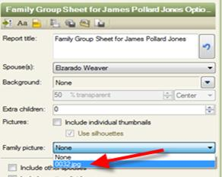
Create a Family Group Sheet by the following:
1. On the Family tab of the People
workspace, select one of the
parents’ names, then click the
Publish tab.
2. Click Relationship Reports, and
select Family Group Sheet.
3. On the right side of the page, click
the Create Report button.
4. Click the Save Report icon under
Family Group Sheet Options. Name
the report; click Save.
5. The report can be opened by
clicking the Publish tab and then
Saved Reports.

Before a photo can be used as the family picture on a Family Group Sheet, it needs to be assigned as Media to the Relationship for the parents.

1. Again, on the Family tab of the People workspace, select the same parent’s name, then click on the Marriage facts button.

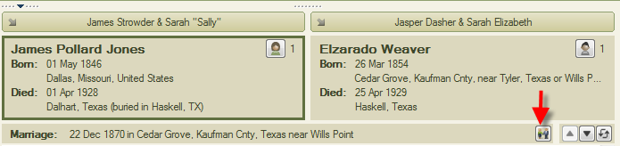
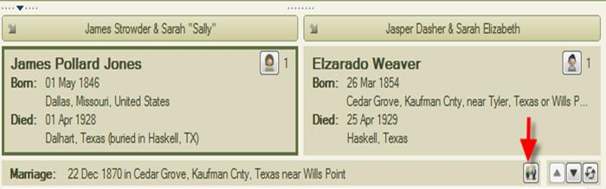

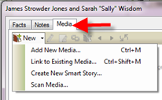
2. In the window that appears, click on the Media tab at the top.
3. Next, click the drop down arrow beside New and select one of the choices: Add New Media (import new photo from a folder on your computer), Link to Existing Media (attach a photo already in your media gallery to this fact), or Scan Media (scan a photo from your scanner).
4. Click OK.
5. Now, to add this photo to the top of the Family Group Sheet, open the Family Group Sheet from the Publish tab, Saved Reports.
6. Click on the Family Picture drop down menu on the right and change it from None to the selected photo.

